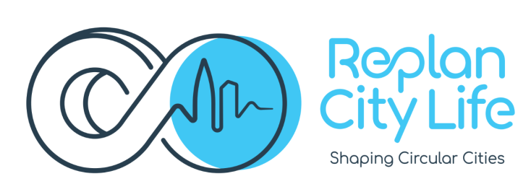

TITLE:
LIFE20 GIE FR 282 - RE-PLAN CITY LIFE
RElevant Audience Plan Leading to Awareness Network for CIrcular Economy Use of Recycled TYre materials in city LIFE

THE PROJECT
RE-PLAN CITY LIFE project aims to raise awareness about the Circular Economy opportunities for Materials, Products and applications obtained from tyre recycling to adopt environmentally friendly behavior and practice in urban communities.
Tyre recycling has some peculiarities that distinguish it from other recycling sectors, as Recycled Tyre Materials (RTMs) are not used to produce new tyres. RTMs produce new materials: rubber, steel fibres and textile fibres, that are used in many different products and applications, from roads and road furniture to sport surfaces, from building materials to infrastructure – and many others.
That has been possible due to efforts by many SMEs around Europe, supported by the Commission through research projects and environmental policies.
Despite these efforts the market did not grow as expected but grew randomly. Some markets have expanded significantly in recent years, e.g. the sport sector, so much that it seems almost saturated. Others, like roads and public works, have not grown enough to represent a stable and reliable demand.

The main focus of the project it to expand the use of RTMs in these areas of applications:
- Transport Infrastructures (roads and rails)
- Concrete and Building (steel fibers reinforced concrete for industrial flooring and roads, rubber sheets and layers for noise reduction, recycled fibers textile panels for insulation)
- Urban and Street Furniture, Sports and Leisure products and applications (sport facilities, rubber surfaces for multisport and leisure activities, etc.)

OBJECTIVES:
The main objectives are:
- Raising awareness among Technicians of P.A., Stakeholders, Policy Makers
- Expanding visibility of the significant works done with RTMs and new ecological applications
- Promoting Green Public Procurement
- Implementing Circular Economy principles for recycled tyre materials (RTMs).

PARTNERS
The project is coordinated by ETRA and includes 12 partners across 6 EU countries, bringing together government authorities, SMEs and technicians in the RTMs industry.
The partners are: COMSA (ES), Fondazione Ecosistemi (IT), Città Metropolitana di Torino (IT), Ferrocarrils de la Generalitat de Catalunya (ES), IASLIM (SI), IETU (PL), ITEC (ES), KERIDIS (GR), The Region of Crete (GR), Politecnico di Torino (IT), Universita' di Torino (IT) WMRC (PL).

The project total budget of € 2.641.170. It started on 1st January 2022 and will last 42 months until 30th June 2025.
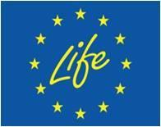
LIFE20 GIE FR 282 - RE-PLAN CITY LIFE project has received
funding from the LIFE Programme of the European Commission

More information on:
www.re-plancitylife.eu
https://www.linkedin.com/showcase/replan-city-life/

Options for accompanying images to add to the site:
